CS 340 README

Use this template to complete your README file. When completing the template, keep the headings as they are so that your document has clear organization. Remove the italicized prompt text after you have completed each section for a polished final document.

About the Project/Project Title
This is the Grazioso Salvare Animal Tracking Dashboard V1 – MongoDB CRUD Module. This project is a python-based CRUD (create, read, update, delete) application that provides the user with an easy-to-use interface for interacting with a MongoDB database. The module is designed to support animal identification and record retrieval workflows. For example, an application supporting Grazioso Salvare could query the AAC dataset for dogs that meet specific criteria, such as breed, age, or other characteristics. The written python module contains an AnimalShelter class that establishes the user connection to a database and provides the methods needed to insert new records, retrieve existing, update existing records, and deleting one or many records that fit a specific criteria. The create() method solely focuses on the steps needed to insert a new record into the animal’s collection. The retrieve() method returns results that match given key/value pairs in its query. The update() function provides the ability to update many documents that match a certain filter or multiple filters while also being able to update many fields of a document. The delete() function provides the ability to delete many documents that match a specific filter easily. Although the application was created for the Animal Shelter application, it is designed to be reusable and can easily be incorporated into larger applications. This application allows user access as it takes a username and password input and roles can be configured for each account in MongoDB.

The dashboard supports three animal rescue categories: water rescue, mountain or wilderness rescue, and disaster or individual tracking. Users can select a rescue category using the dashboards radio-button filters. The application then displays records matching the selected criteria users can also reset the filters to return to the full dataset. The dashboard also includes an interactive data table that supports pagination and row selection. A breed chart summarizes the most common breeds in the bar chart, while a geolocation map displays the selected animals’ location using its latitude and longitude coordinates. The map can display identifying information like the animal’s name and breed. The dash provides the view and controller structure of the dashboard. The view consists of the visual components displayed to the user, including the radio-button filters, data table, breed chart, and geolocation map. This structure separates the user interface from the database operations handled by the AnimalShelter class. As a result, users can interact with animal records through the dashboard without directly writing database queries.

Motivation
The motivation for this application was to create a useful tool for connecting a python application to MongoDB while also allowing for reuse in different databases. I feel this approach provides a more organized and maintainable way of interacting with databases. It also was a great demonstration of how different languages and tools can be used together to achieve goals much easier. As always best practices were followed in this application for easy-to-read function and method names to help with any other user who intends to modify or use this application for their own purposes. Python and PyMongo were used to connect the application to MongoDB and implement database operations. Jupyter Notebook provided a convenient environment for testing the class interactively, inspecting returned records, and verifying that database operations produced the expected results.

MongoDb was selected because its document-based storage structure works well with the Python dictionaries used to represent animal shelter records. Each animal record contains key/value pairs, like animal_id, animal_type, breed, color, and sex_upon_outcome. This allows for information to easily be passed into the database without the need of any conversion. Python and PyMongo were selected because the readable syntax and dictionary data structures make it straightforward to represent animal records and organize database operations into reusable methods. PyMongo provides the connection between Python and MongoDB, allowing the AnimalShelter class to perform database operation like insert_one() and find(). Jupyter Notebook was selected because it provides an interactive environment where code can easily executed one cell at a time and the results are displayed immediately beneath that cell. This made testing much easier and faster when verifying functionality of the module. Because MongoDB’s find() method returns a cursor, converting the cursor to a list allowed me to inspect multiple matching records directly in the notebook. This helped to verify both the database query and the format of the returned data before moving forward. Dash was selected to build the web interface in Python. It provides components for tables, charts, maps, and user controls, while callbacks connect user interations to application logic. This makes it possible to update displayed data when a user selects a rescue category or select an animal in the table.

Getting Started
The project uses the following software and Python libraries:
- Python
- MongoDB
- PyMongo
- Jupyter Notebook
- JupyterDash
- Dash
- Pandas
- Plotly Express
- Dash Leaflet

This project uses the Austin Animal Center (AAC) animal shelter dataset to puplate the MongoDB database with animal records. Before running the python module, the dataset must be imported into the aac database and stored in the animals collection. The dataset provides the animal information used to test database operations and demonstrate how records can be retrieved by specific search criteria.
The dataset should be imported using MongoDB’s import tools. After importing the data, verify that the animals collection contains records before testing the AnimalShelter Class. This ensures that retrieval queries have data available to return and that the CRUD operations can be testing against the intended database.
To reproduce this project, the user needs to have MongoDB, Python, PyMongo library, and Jupyter Notebook installed. The user must also have an account created for accessing their database. For example, the python module provided uses a user with the account name “aacuser” with a password of “password”, and the project also points to the database “aac” with a collection focus on “animals”. The assigned account must also have the appropriate read/write access for accessing the databases and collections desired. An example of where to edit these variables can be seen here:

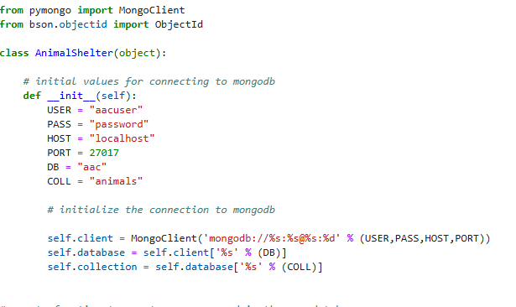

The MongoDb user account must be created and assigned the appropriate database permissions before the application can connect successfully. The username and password configured in the Python module must match the account before the application can connect successfully. If the credentials or permissions are incorrect, the connection or database operations may fail.

The retrieve or read method was created using MongoDB’s find() method. One issue with this was that this method only returns the MongoDB cursor rather than an actual list. This was addressed by converting the cursor to a list and then returning that back to the user. This allowed for multiple matches to be returned instead of only a singular document. This is how it was achieved:

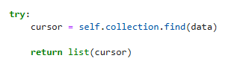

The create() method inserts a new animal record into the MongoDB collection using the insert_one() method. It accepts a python dictionary containing the fields and values for the new document. For example, the dictionary may contain fields such as animal_id, animal_type, and breed. When the method calls insert_one(data), MongoDB attempts to insert the supplied dictionary as a new document rather than searching for an existing document with matching values. The function checks if the data parameter is empty if so it will raise an exception and return false, while a true result would insert the data into the database.

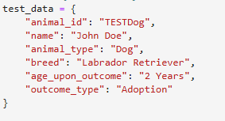
The update method was created using the MongoDB update_many() function. This method takes the filter query and update values and updates every document that matches the filter query provided. The following test case was created using the filter query and update values:

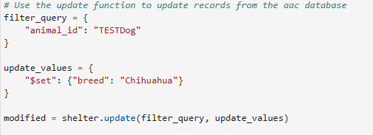

The delete method was created using the MongoDB delete_many() function. This method takes a similar filter query to look for a document containing a matching data value and deletes all of the documents that contain that value. For this example a simple search for any “animal_id” that matches the “TESTDog” ID and deletes them appropriately.
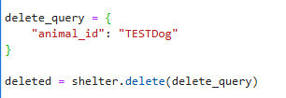

One challenge I encountered during the development of this project was that MongoDBs

Installation
Several tools and software were used to make this application and are needed to replicate it. Python was used as the primary programming language and will require installation on a local system. Python was used to create the main script and the testing script. MongoDB will need to be installed on the system as the application is useful for accessing its databases and documents. PyMongo will need to be installed on the system as the module provides the drivers needed to connect python applications to MongoDB databases. PyMongo is also responsible for the main functions of the script like find() and insert_one() and provides authentication support. Jupyter Notebook was also used to create and execute the testing operations.

Usage

Code Example
This module was created using pymongo and python. The main program .py file contains a class called AnimalShelter() that provides the current read and retrieve functions for the application. The necessary modules are imported first and then the __init__ function is created for accessing MongoDB:

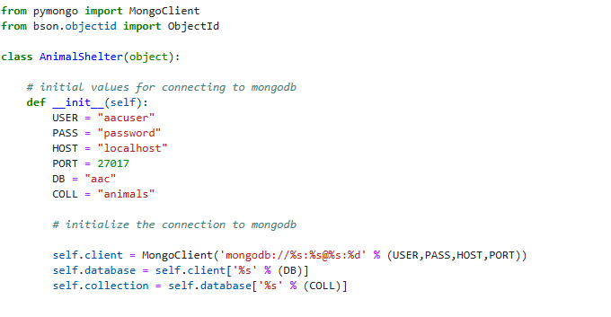

The variables can be edited as needed to ensure your own connectivity to your own MongoDB database as needed. For this project I had a separate user account established in the USER and PASS variables. I have also set the database to access with DB and the collection to access with COLL. After these variables are established, the application attempts to establish a connection to your database.

The create() function can be used to insert a singular document into the database. The function also ensures that the query does not contain empty data, once it has done so it inserts the document and then returns true. If any exception is raised, it produces a “Nothing to save because the data parameter is empty” handling message to the user.

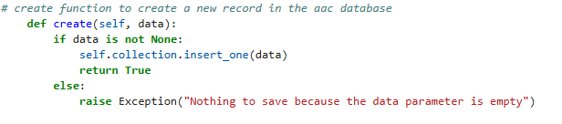

The retrieve() function is used for retrieving a document that matches specific data found in the database. If no data is provided for the search then the program returns and empty list to the user. If data is found in the query it will find the data and set it to a variable named cursor as the cursor is what is returned from a find() query. The cursor is then converted to a list and returned to the user. If no data is found then the program produces an exception and returns an empty list.
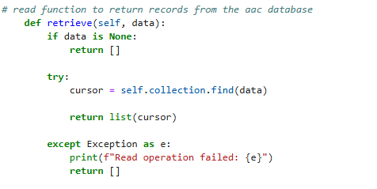

The update function provides the ability to update many documents that match a filter query. This function accepts two inputs the filter query to look for matching documents and the data to inserted to update the document. First the function checks for any empty data contained in either variable, if empty data is found it raises an exception to notify that data is missing. When the correct data is passed into the function, the function continues and tries to update the document, when a successful insertion is completed, it returns the number of documents that were updated. If an error occurs during the update, then an exception is raised and the error is returned to the user.

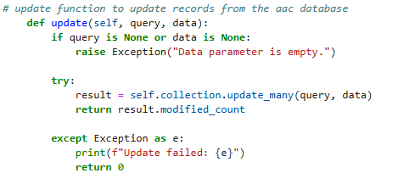

The delete method uses the MongoDB function delete_many(). This function allows for a filter query to be searched, and all the matching documents are deleted from the database. First, the function looks for any empty data given, if empty data is found then an error is returned to the user. If the needed data is found, then the program moves to try and call the update function into the variable “result”. This variable is then returned to the user in the form of a how many documents were deleted from the database. If for any reason an exception is raised that exception is returned to the user and the function terminates.
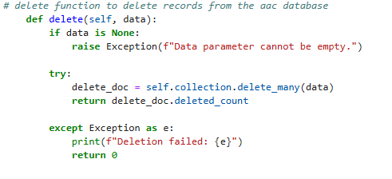

Tests
The AnimalShelter class provides the create and retrieve functionality for the application. The .py file can be downloaded and imported into a python program or jupyter notebook for testing and instantiated using the following:

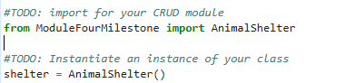

To run a simple document creation test the following dictionary with its associated key/value pairs can be passed into the create() function and verified like so:

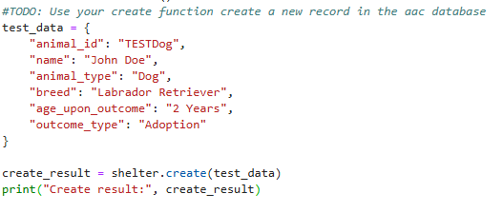

Running this test would create a response that would say “Create Result: True” or it may say “Create Result: False” depending on whether or not the document was successfully created and inserted.

Another example would be a test on the retrieve function. This time the query I used was to test if the document that I had just created could be retrieved. The query accepts the same dictionary key/value pairs, and I searched the document by the “animal_id” of “TESTDog”:

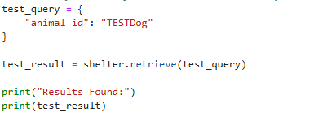

An example of both tests running one after another and producing the correct output would look like the following:

An example of a full test against the CRUD system is provided below. This test was written to who the full functionality of the create, read, update, and delete functions of this application. This example at first creates a record, pulls the record that was just created, updates the breed of the dog to “chihuahua”, displays the updated record for verification, and then deletes that newly created record to further explain the use case of this application.
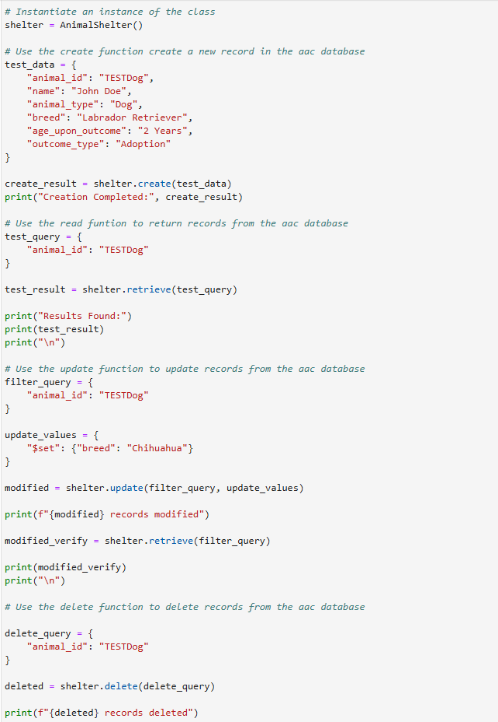

The following is the output created by running the full test against the python module:

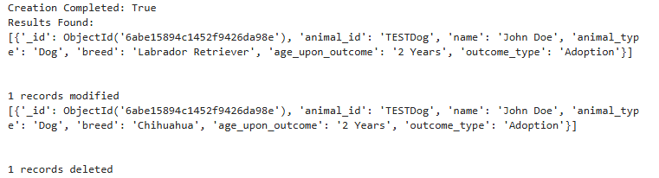

Testing was also completed for the dashboard elements to ensure that all functionality was intact. The tests focused on confirming that the dashboard loaded records correctly, that filters returned the expected results, and that the table, breed chart, and map responded to user interaction. The unfiltered table was checked to verify that the dashboard could display the complete dataset. Each rescue-category filter was tested separately, and the reset control was used to restore the original view. The map was tested by selecting a record and confirming that the displayed location used that records geographic coordinates and the animal information was displayed.

(Original view with all records displayed – 1000 pages.)
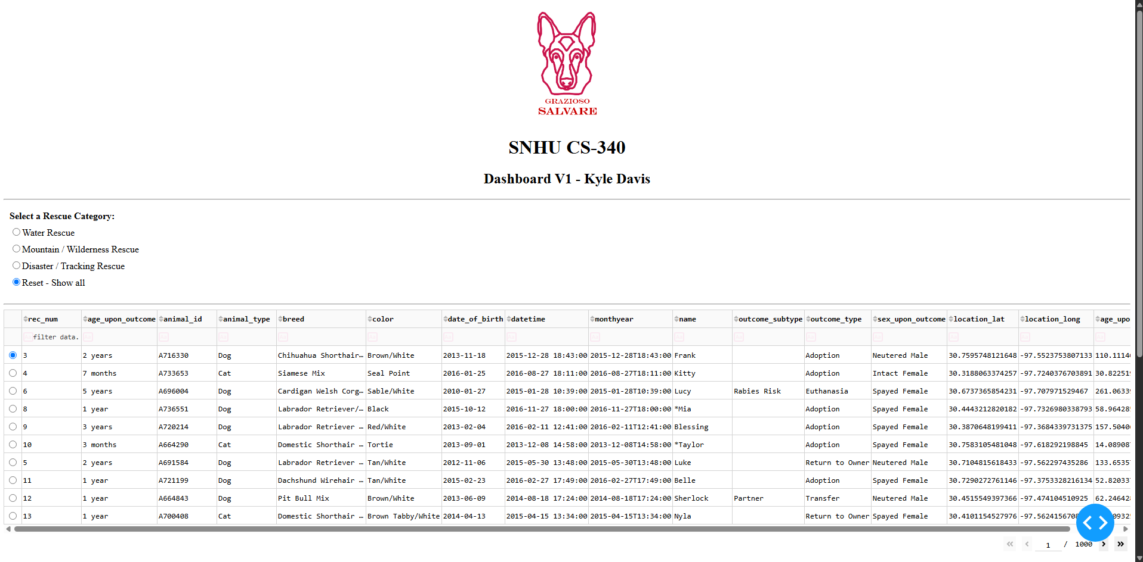

(The water rescue filtered view)
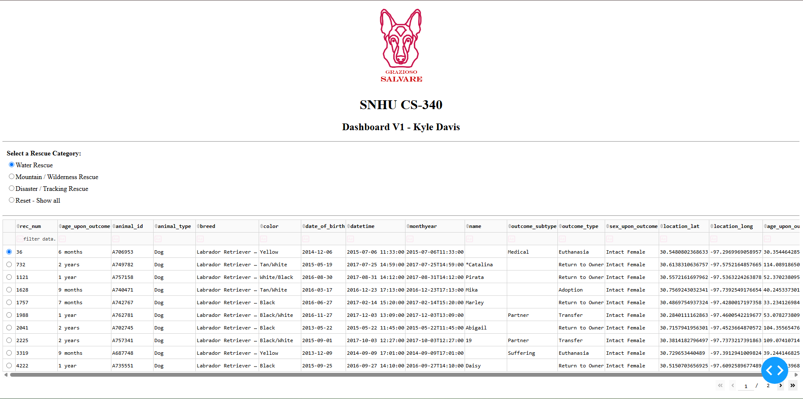

(The mountain / wilderness filter view)
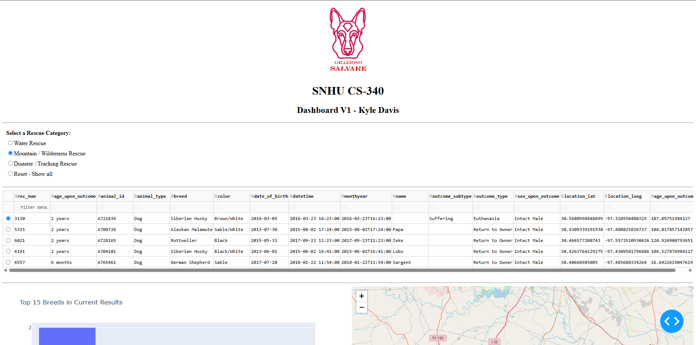

(The disaster / tracking filter view)
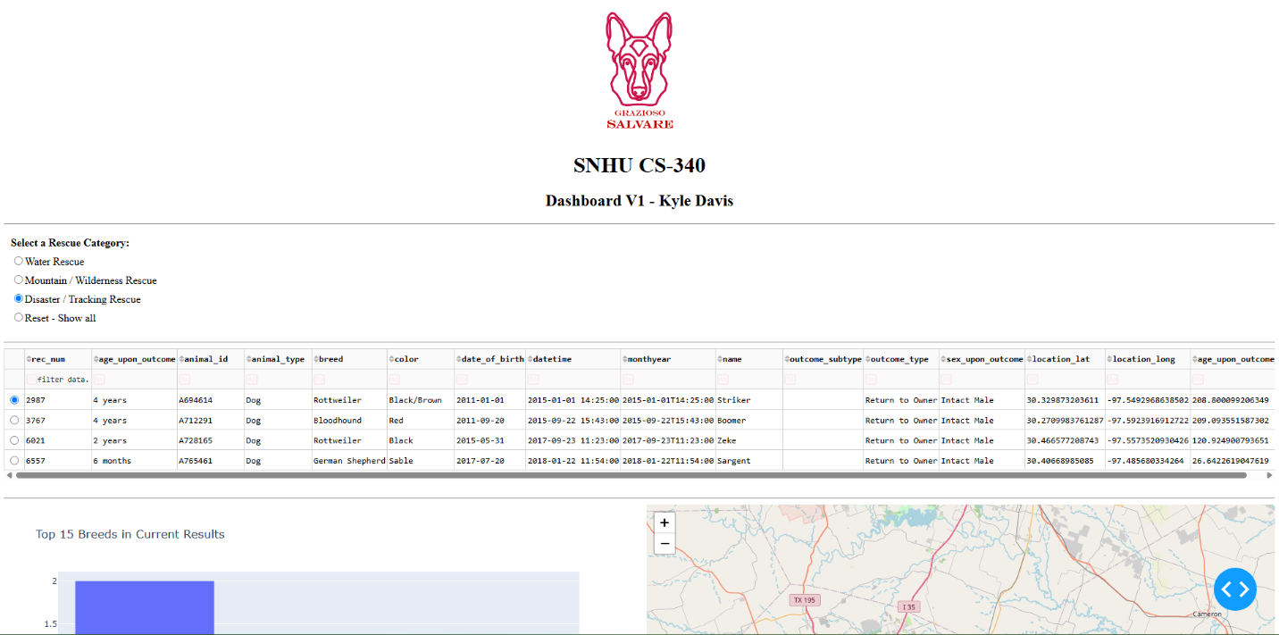

(Example view of graph and map with all records – non filtered.)
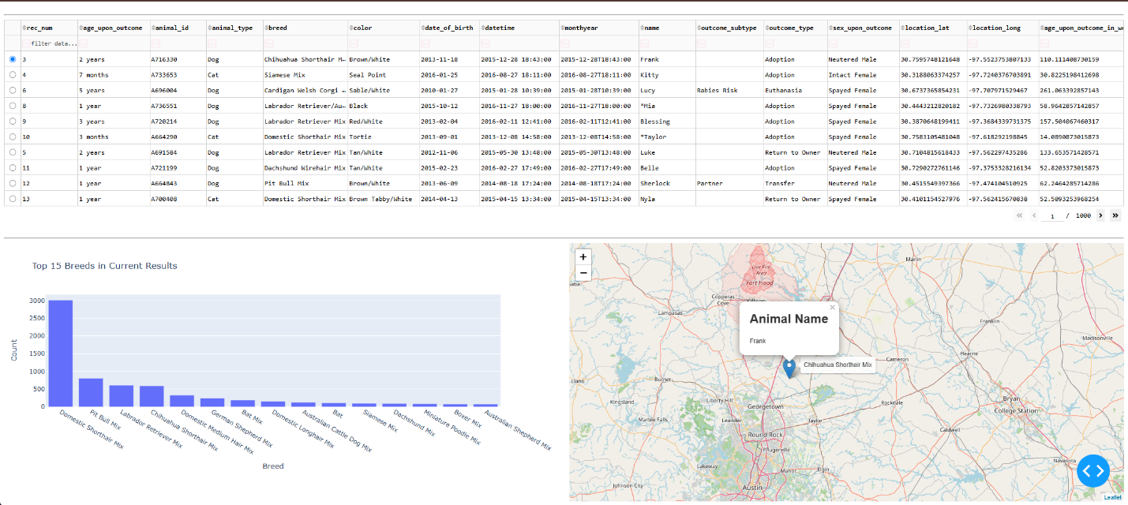

(Example view of map and graph with a filtered view using mountain / wilderness filter option)
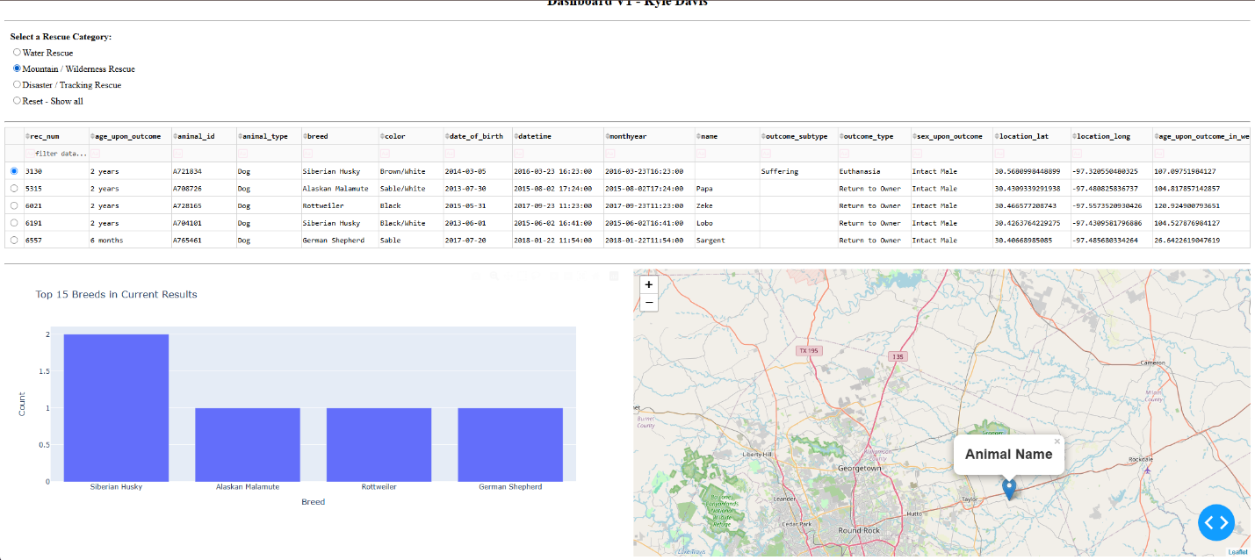

One challenge encountered during the development was handling the filtering logic for the rescue categories. Each category required its own combination of animal characteristics and criteria. The filter conditions had to be corrected so that each selection used the appropriate criteria. The dashboards logo also required attention during development. An error occurred when encoded image data was treated as a string even though the base64 encoding function returned bytes. Converting the endoding bytes to utf-8 string resolved the issue and allowed the image data to be used in the dashboard. I also wanted the two graphs to dynamically size themselves based on the users’ screen their accessing from so if a smaller screen is presented the widgets would stack on top of each other for easier viewing. This looked like this once it was completed:

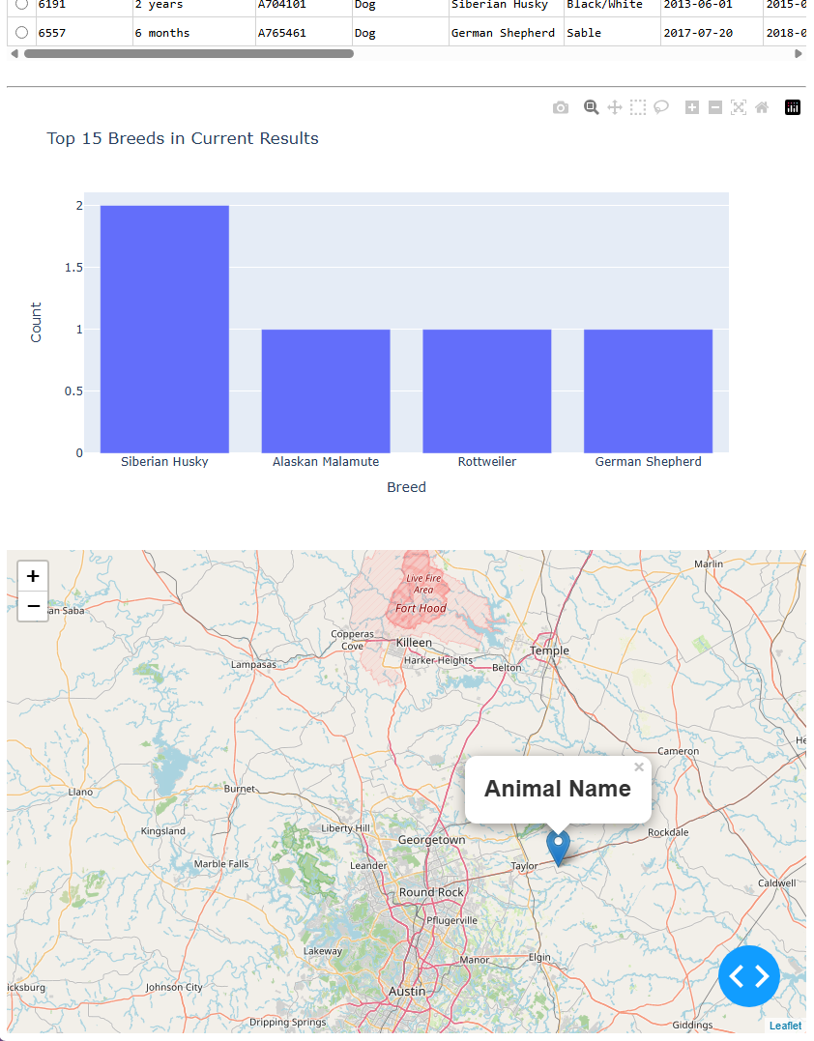

Documentation and Resources

The following documentation and resources were used to develop the Grazioso Salvare Animal Tracking Dashboard:

Python: https://docs.python.org/3/ — Used for the programming logic and data processing.

MongoDB: https://www.mongodb.com/docs/ — Used to store and manage animal shelter records in a document-based database.

PyMongo: https://www.mongodb.com/docs/languages/python/pymongo-driver/current/ — Used to connect Python to MongoDB and perform database operations, including creating and retrieving records.

Jupyter Notebook: https://jupyter.org/documentation — Used to develop and test the dashboard in a notebook environment.

Dash: https://dash.plotly.com/ — Used to build the dashboard interface and callbacks that update components based on user interactions.

JupyterDash: https://github.com/plotly/jupyter-dash — Used to run the Dash application within the Jupyter environment.

Pandas: https://pandas.pydata.org/docs/ — Used to organize retrieved animal records into a DataFrame for filtering and display.

Plotly Express: https://plotly.com/python/plotly-express/ — Used to create data visualizations for the dashboard.

Dash Leaflet: https://www.dash-leaflet.com/ — Used to display geographic information on an interactive map.

Roadmap/Features (Optional)
Provide an open issues list of proposed features (and known issues). If you have ideas for releases in the future, it is a good idea to list them in the README. What makes your project stand out?
Note: This section is optional for the purposes of this assignment. If you choose not to fill out this section, remove it from your final README file.

Contact
Your name: Kyle Davis

